**12 - R710 Proxmox VM – Ubuntu Workstation with STATIC IP**

**Log in to Proxmox:**

1. In Firefox, go to : https://192.168.124.**201**:8006

User: root

Password : <whatever>

**Storage area for uploading ISO’s into**

1. Download the required Ubuntu Workstation 64 bit LTS to local PC end then click the “Upload” button to end up with something similar to:  
   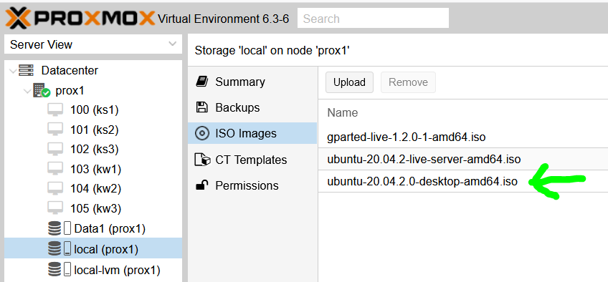

**VM – Full Virtual Machine ( Ubuntu 20.04 LTS )**

1. This example covers a single VM for development work, etc of apps to run in Kubernetes cluster.
2. With ‘prox1’ node selected, click “Create VM” and fill in Name, thus (ensure Advanced is ticked):

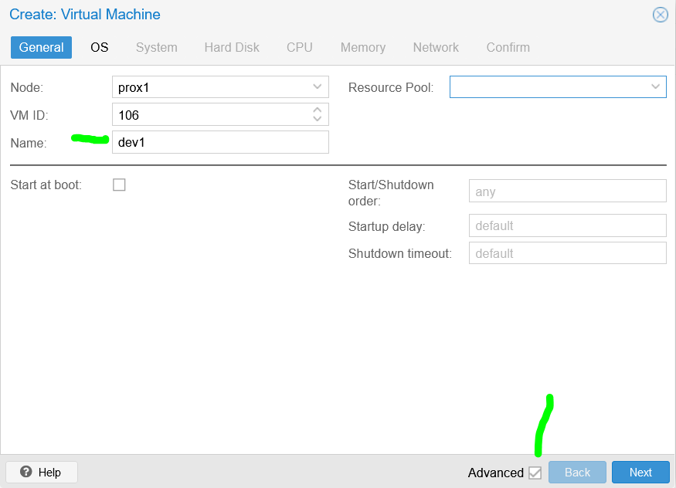

1. Select the ISO image to install from:  
   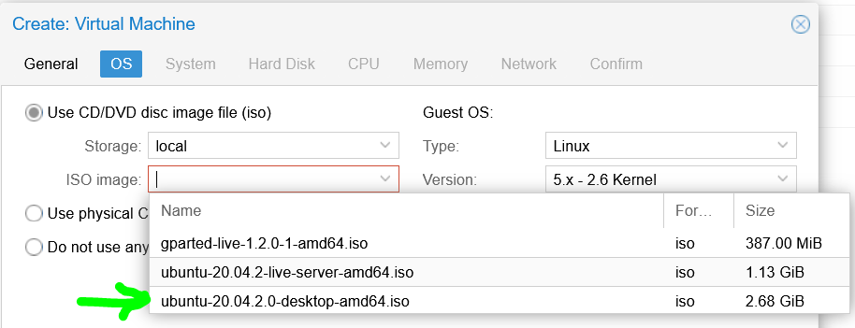
2. Leave System as is:  
   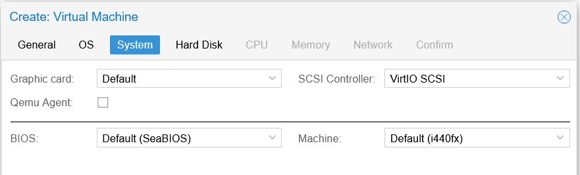
3. Hard Disk, adjust to 80GiB **AND** set storage to be **local-lvm AND** set the Bus/Device to **VirtIO** Block (for better Linux performance):  
   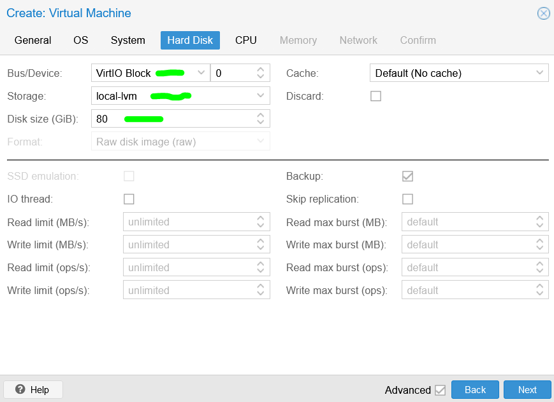
4. CPU, adjust as follows (host for virtualisation pass through):  
   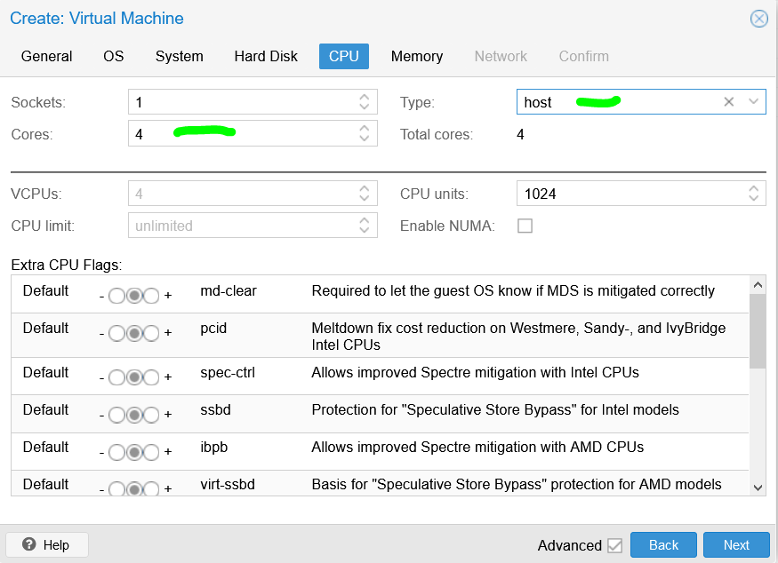
5. Memory, adjust as follows:  
   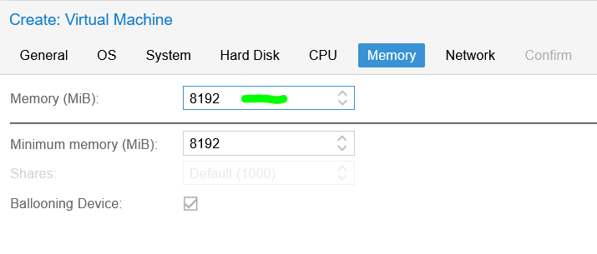
6. Leave Network as is:  
   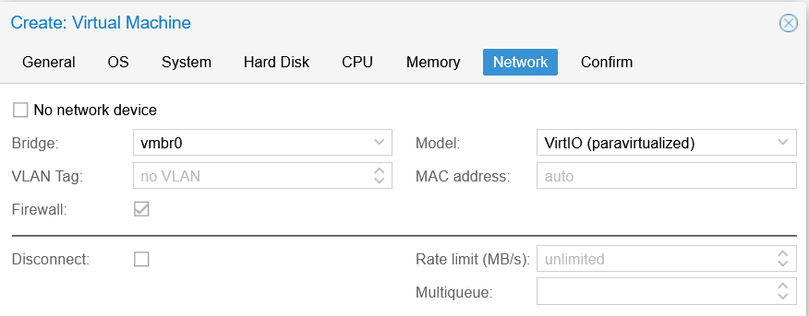
7. And on Confirm, click Finish, to get to this::  
   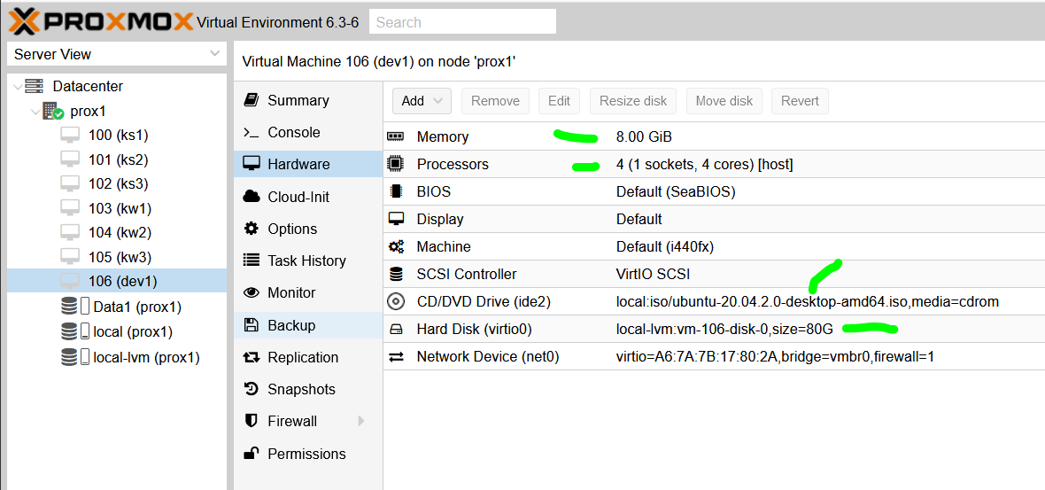
8. Select dev1, click on Console to get:  
   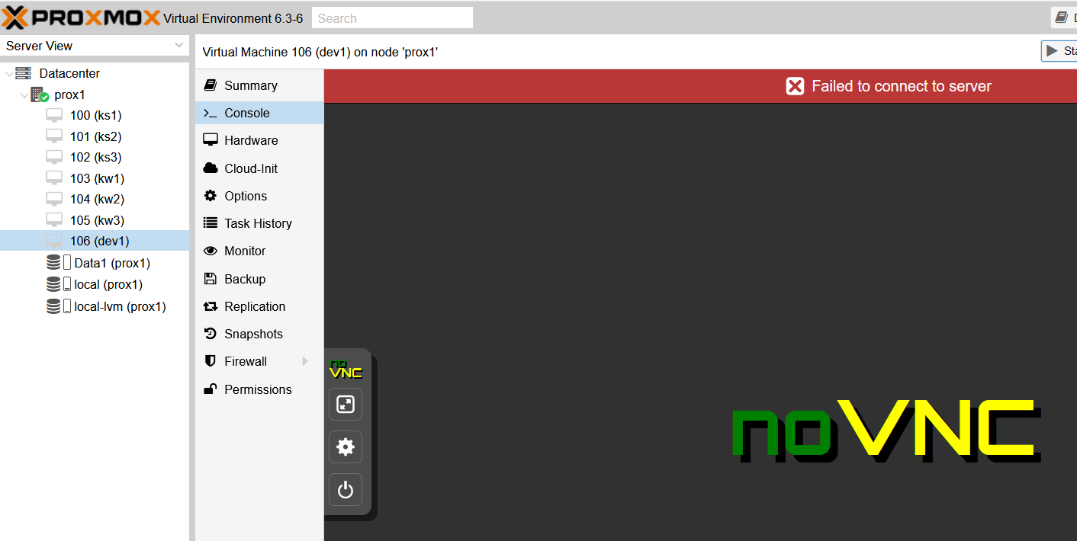
9. Click on Start, Ubuntu will start to install … and gets to the first screen:  
   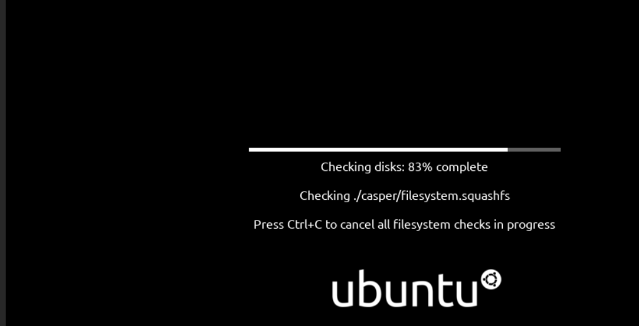
10. On this screen:  
    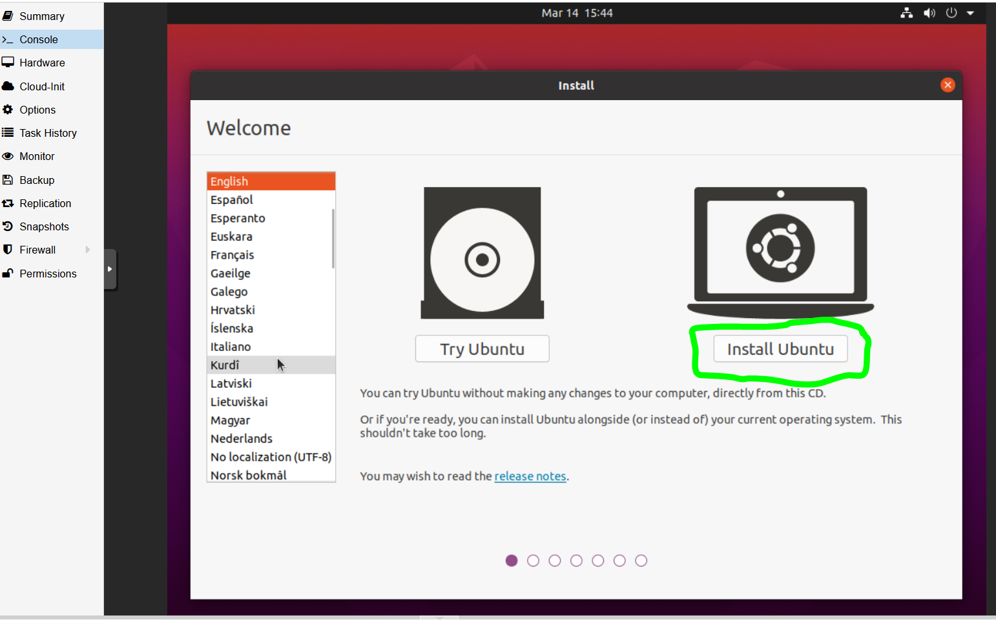  
    Click on “**Install Ubuntu**”
11. On this screen:  
    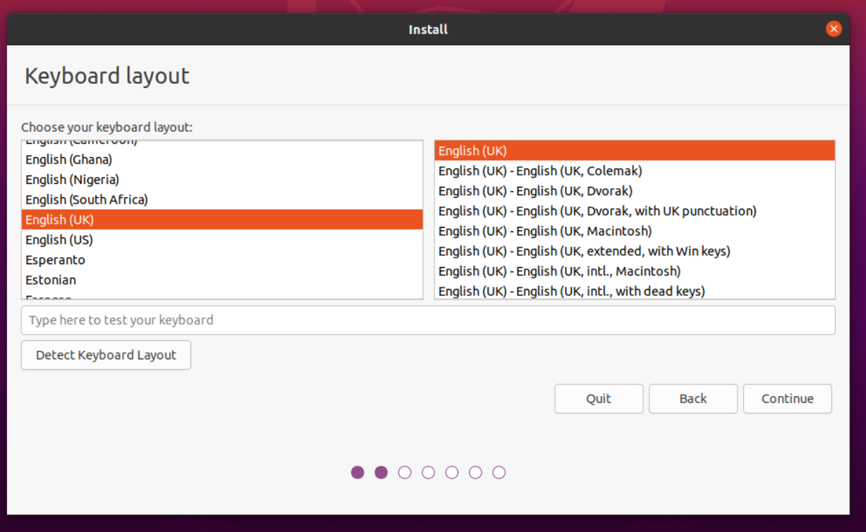  
    Click on “**English (UK)**” in left hand column and then click on **Continue**
12. On this screen, leave settings as is:  
    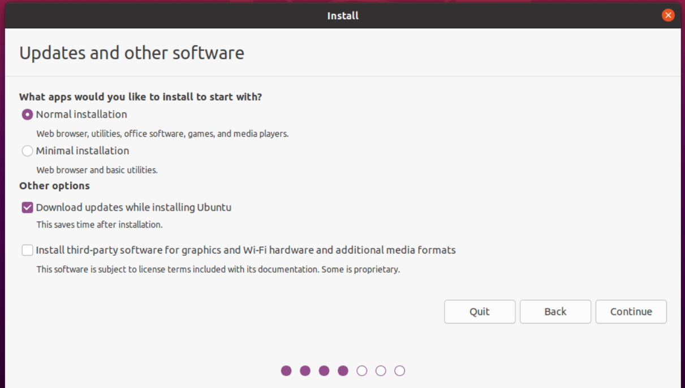  
    and click **Continue**
13. On this screen, leave settings as is:  
    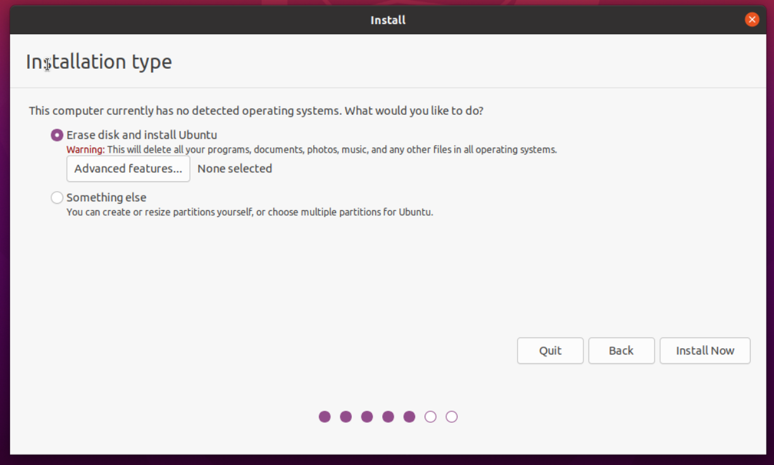  
    and click “**Install Now**”
14. On the popup window:  
    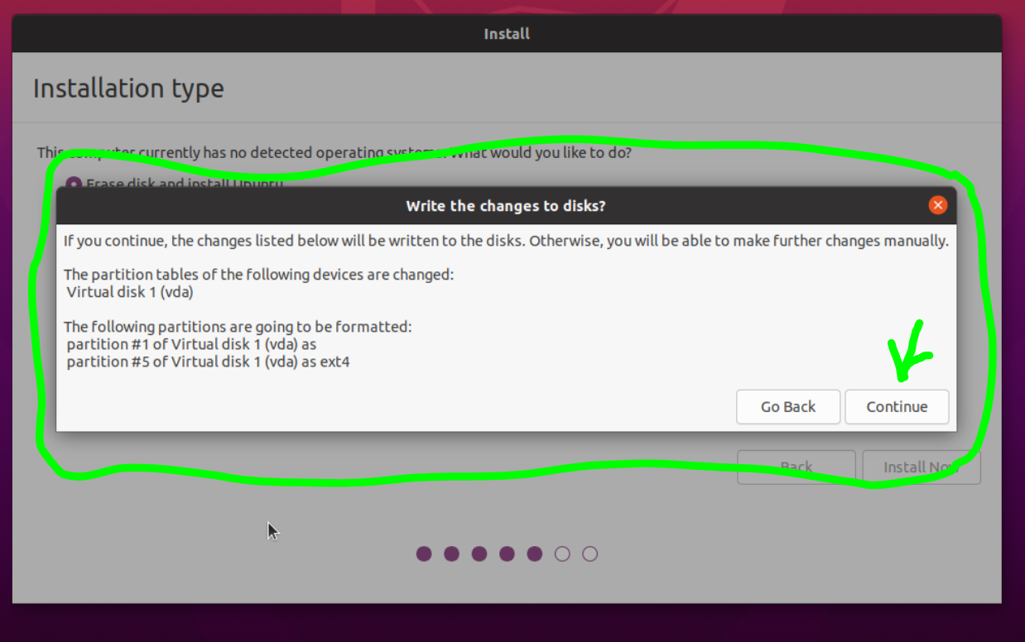  
    click **Continue**
15. On this screen, select **London**:  
    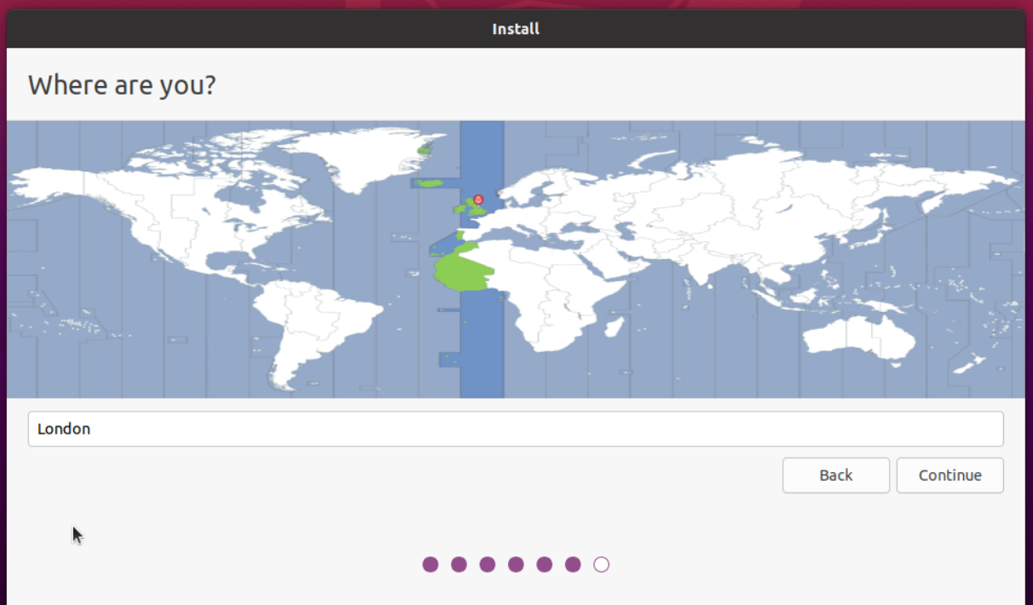  
    and click **Continue**
16. Fill in details on this screen (set computer name to: **dev1**):  
    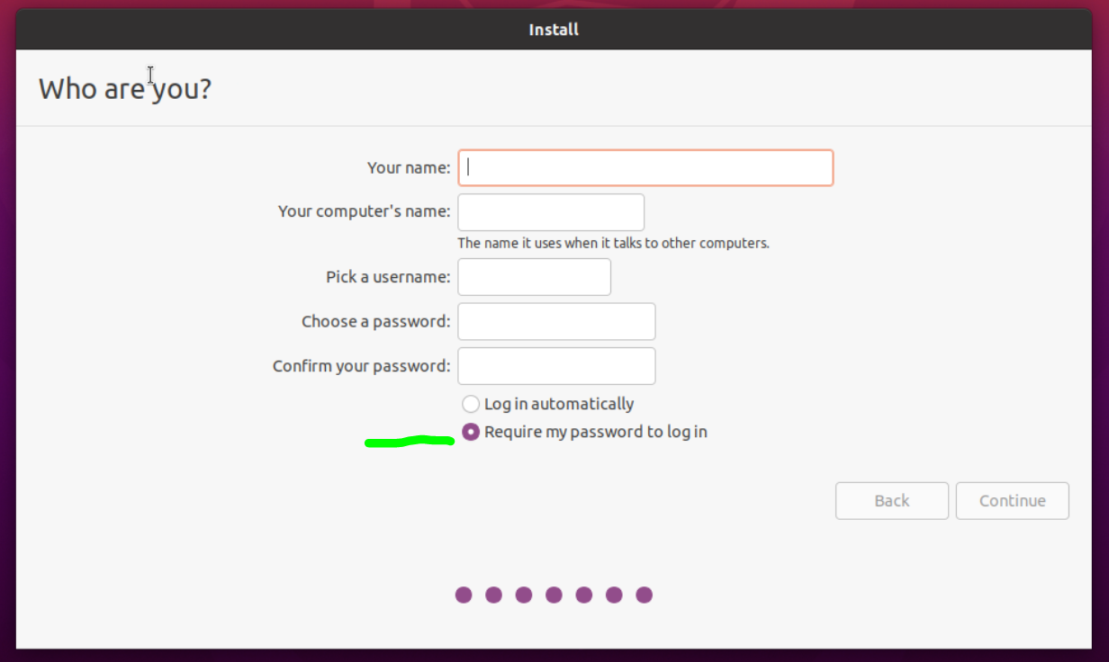  
    and make sure “Require password” is selected, and click **Continue**
17. The OS will now install, and eventually get to:  
    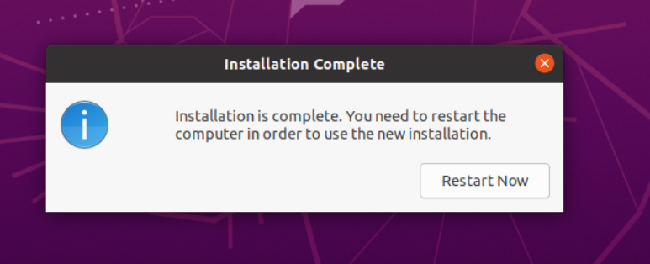  
    so, click “**Restart Now**”
18. You will be presented with:  
    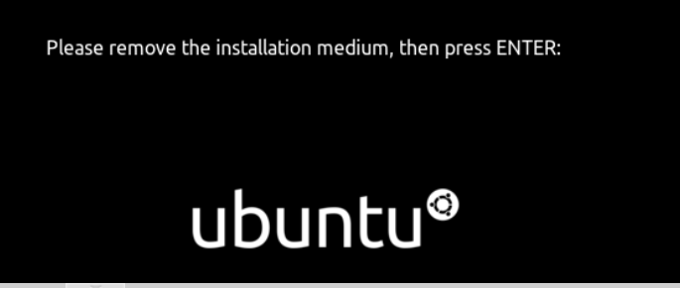  
    so, press **ENTER**
19. You will now see the logon screen:  
    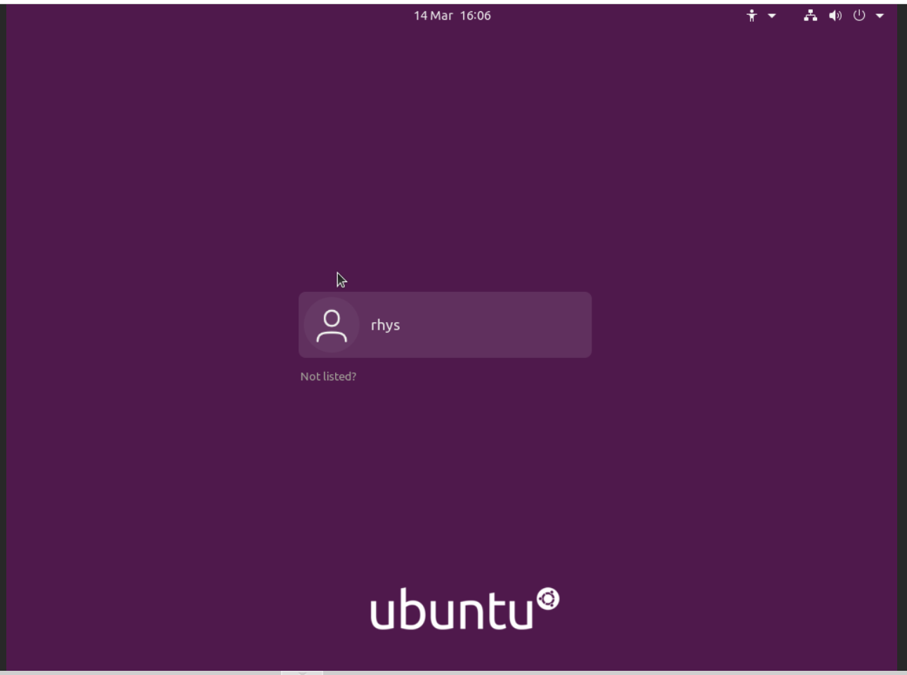  
    Click on the user name, and proceed …
20. On this screen:  
    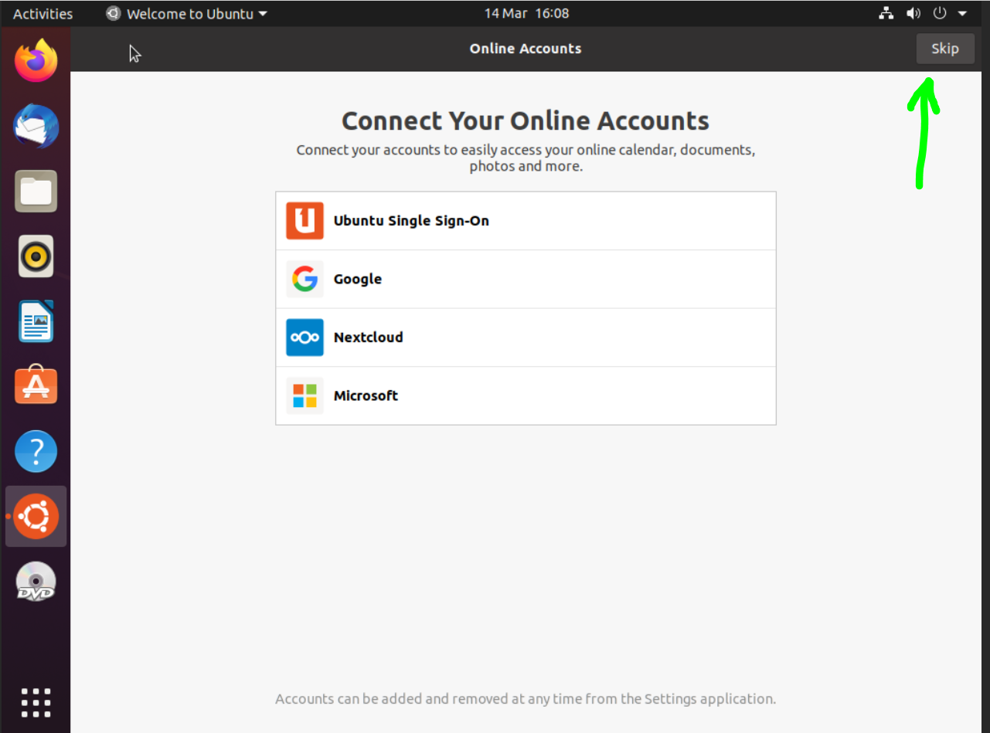  
    click on **Skip**
21. Next you are asked to setup live patch, so click on **Next** to skip this:  
    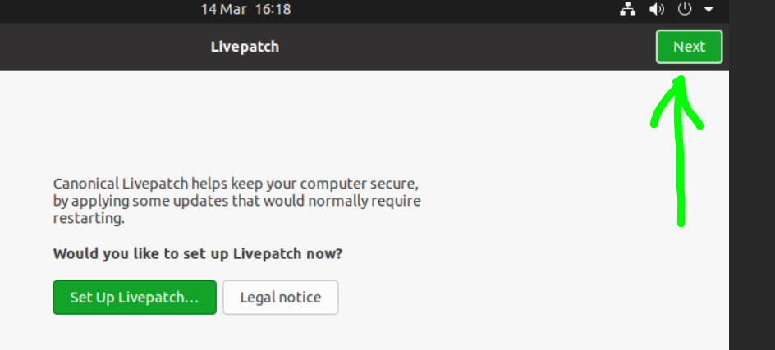
22. On the next screen, ensure the following is selected and click **Next**:  
    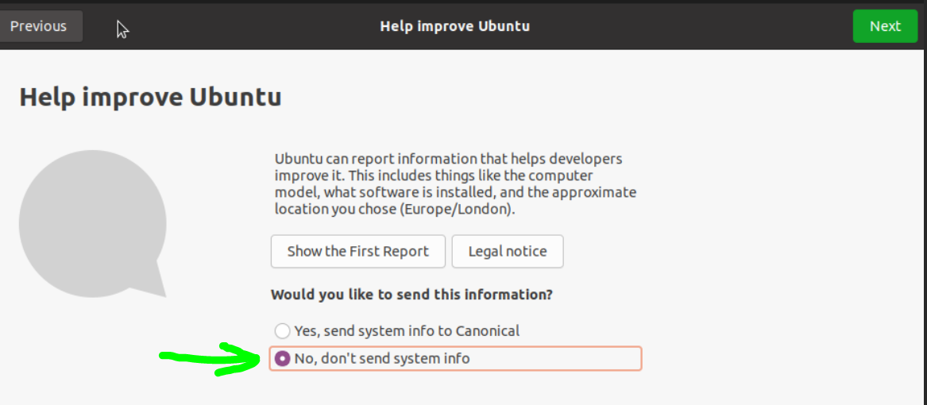
23. Leave **Location Services** un-selected and click **Next**:  
    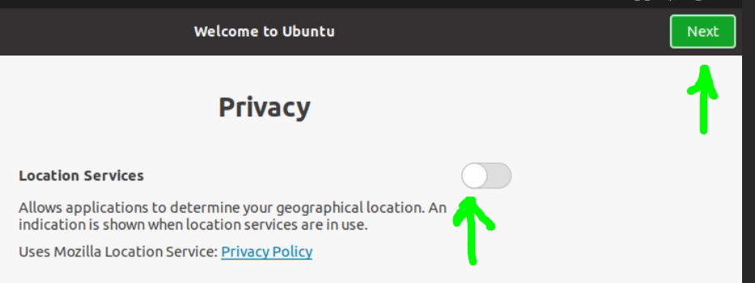
24. And on this click **Done**:  
    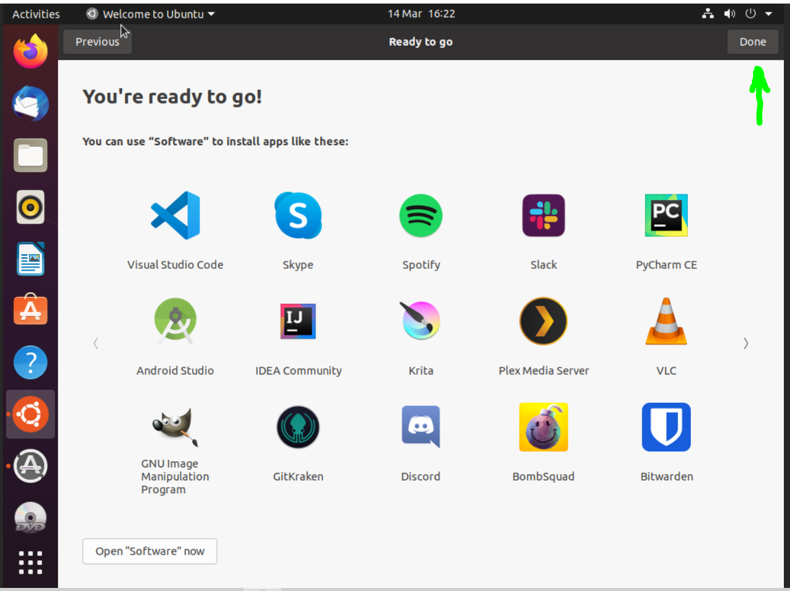
25. For the “**Software Updater**”, click on **Install Now**:  
    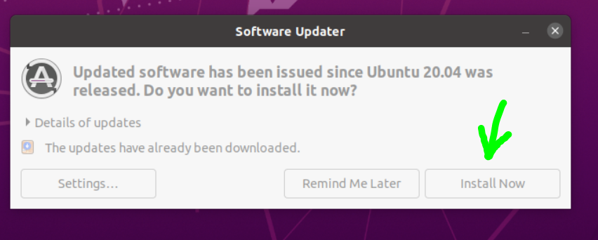
26. Once the software update is complete, carry on.
27. The VM stored in the “local-lvm” which is of type LVM-Thin (which does not pre-allocate all of the storage space – it is allocated as needed).
28. Do CTRL-ALT-T to open a terminal and as root do:  
    **sudo usermod –aG sudo <user name>**
29. Log out and back in again for above to take effect.
30. Follow the rest of the instructions below:

-=-=-

**Changing IP address on Ubuntu 20.04 LTS**

See this article:

<https://www.tecmint.com/set-static-ip-address-in-ubuntu/>

and work through it to setup the following settings:

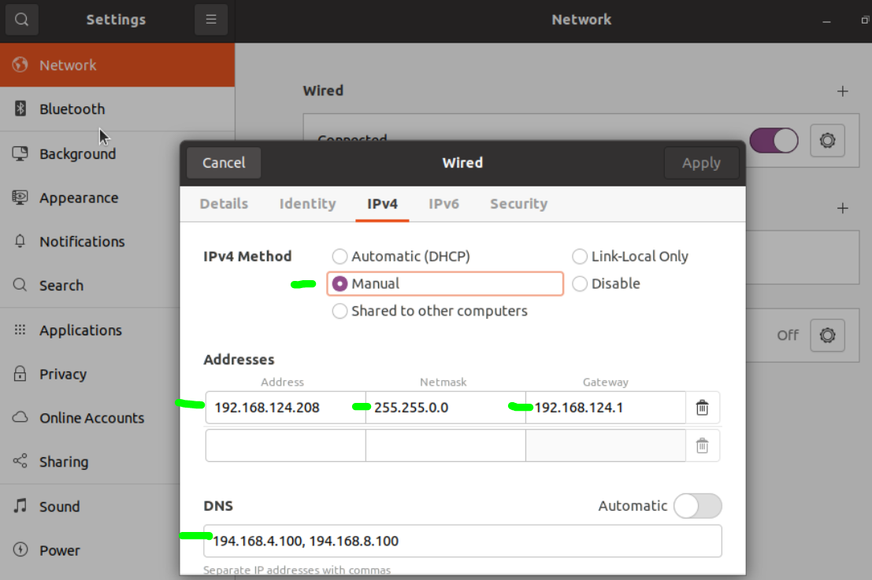

On the left of the screen, Eject the install DVD and then Power off the machine (top right drop down).

On the next power up, the new network settings will take effect.

-=-=-

# Enabling SSH on Ubuntu:

**sudo apt update**

**sudo apt install openssh-server**

**sudo ufw allow ssh**

-=-=-

## Enabling Remote Desktop Access from Windows

**sudo apt install xrdp**

**sudo systemctl enable --now xrdp**

**sudo ufw allow from any to any port 3389 proto tcp**

NOTE: Before opening Remote Desktop from windows, ensure you are not logged into the GUI within Proxmox Console.

-=-=-

## Enable GNOME Classic Mode

**sudo apt install gnome-shell-extensions**

logout, and from login screen, click the cog icon and select “GNOME Classic” session.

-=-=-

## Other commands to install

**sudo apt install net-tools**

**sudo apt install curl**

-=-=-

## Update in one line:

**sudo -- sh -c 'apt-get update; apt-get upgrade -y; apt-get autoremove -y; apt-get autoclean -y'**

**NOTE:** in the above, the space after the double dash after sudo is correct

-=-=-

## Prevent further auto updates:

**sudo apt remove unattended-upgrades**

Doing the above is important to keep control of the server and not have packages updated that may break some existing installation configuration.

-=-=-

That completes the creation and initial setup of the Workstation VM.